
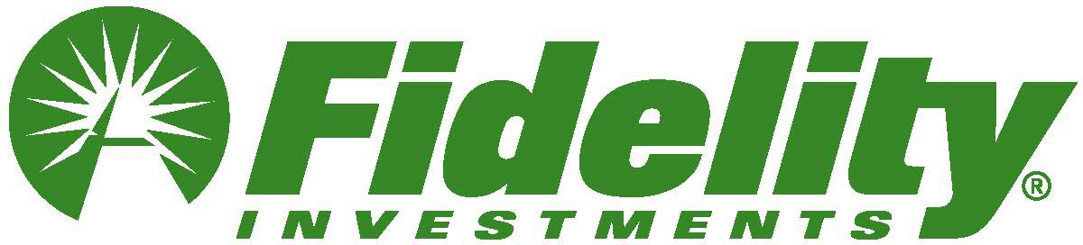
Subject: Learn how to get more from your money

Preheader: Strategies for retirement saving, managing your money, and leaving a legacy.



This Black History Month, take your money to the next level
Explore ways to get more from your money today and into the future with these three on-demand workshops from Fidelity:
- Making the Most of Your Retirement Savings
- Managing My Money
- Preserving Your Savings for Future Generations

Watch now

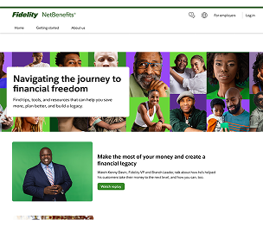

Find additional insights, tools, and strategies at Fidelity.com/Blacklegacy

Privacy Policy Terms of Use

Investing involves risk, including risk of loss.

The information in this email is intended solely for the attention and use of the named addressee.

This message or any part thereof must not be disclosed, copied, distributed, or retained by any person without authorization of the addressee.

Please do not respond to this email. This mailbox is not monitored, and you will not receive a response.

The third-party trademarks and service marks appearing herein are the property of their respective owners.

Fidelity Brokerage Services LLC, Member NYSE, SIPC, 900 Salem Street, Smithfield, RI 02917

© 2025 FMR LLC. All rights reserved.
1181863.5.0

